Unit - 2  
Networking - Report

**___**

By Aaron Mascarenhas

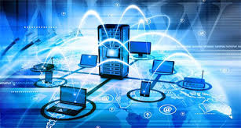

# INTRODUCTION

The objective of this report is to examine networking principles and their protocols by discussing the benefits and constraints of different network types and standards and to also to go through the impact of network topology, communication and bandwidth requirements. The other part will explain the networking devices, operations by discussing the operating principles of networking devices and server types. The inter-dependence of workstation hardware with relevant networking software.

## 

## 

## Task 1 -

A - Explain the advantages and disadvantages of the above network.

* According to the above network diagram, let us look at the Pros and cons of this structure.

**Advantages -**

* This structure improves the capability of the data centres by strengthening it security.
* As this structure has 3 routers on it, it might make transfering file faster, if the switches has proper control over the flow of data. Replacement of a damaged router can be made easily as there are routers to support
* It makes the IT service department can provide better services to the user and maintain, track and manage the traffic flow of data through the network .
* The IT service department works in an efficient and effective manner as the network structure is better built.

**Disadvantages -**

* It is not as efficient as there is only one IP address for multiple PC system which are connected to each switch, which in turn can confuse the router to send a packet to a specific PC.
* There is only one cloud server, which will cause a lot of traffic if all the PC systems send data signals at the same time.
* As there are a too many systems connected to th network, it cause an interference with the signals from other systems to communicate with each other.
* Since the systems are on the LAN connection the systems are supposed to have different IP addresses as the signals might conflict with each other.

B - Explain the following networking standards.

* **OSI Model** -

The main reason OSI is used, is because it **helps the sellers** and especially for people who work at the back-end which **fully fleshes-out** the the instructions to produce programs, which have an **understandable overview** of the network.

There are layers in the open system which are :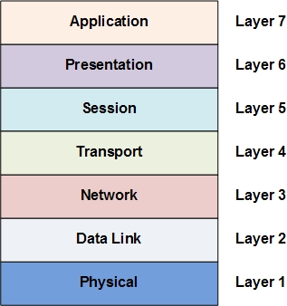

**Layer 7 - The Application Layer -**

This layer performs a set of services to the application which is not part of itself, instead it directly uses this service to **gain access** to the network.

**Layer 6 - The Presentation Layer -**

In this layer, the OS is part of the layer itself, which **handles all the traffic** packets which come in and go out which are from one format to a different one.

**Layer 5 - The Session Layer -**

This basically stops conversations which are traffics, and reconnects after an interrupt, these are usually **TCP** which are **Transmission Control Protocol** and **UDP** which are User Datagram Protocol, which help support services for programs.

**Layer 4 - The Transport Layer -**

It handles data which are in packets , and then **transports the data** while making sure it **rids from errors** before it reaches its destination.

**Layer 3 - The Network Layer -**

In this process, it manages the **routing of data as well as addresses the data**, which receives and sends transmissions in the form of packets.

**Layer 2 - The Data-Link Layer -**

It is connected with the physical network layer, by **sending packets** to the network framework.

**Layer 1 - The Physical Layer -**

In this layer, transfers **“bit stream”**.which travel through the network using radio like waves.

* **TCP/IP Model** -

It is the same process as OSI model, the only difference is there are few layers compared to OSI model. It is more common used in the modern networks,which uses **Internet Protocol** (IP) to communicate.

The TCP/IP model has only **4 layers** which are -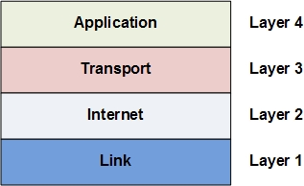

**Layer 4 - The Application Layer -**

It is the top-most layer in this model, it **manages all process communication function**, which are performed by different parts of the layer along side with the OSI model.

**Layer 3 - The Transport Layer -**

This layer is related from the OSI model, its **main functions are common protocols** like (**TCP**) Transport Control Protocol and (**UDP**) User Datagram Protocol.

**Layer 2 - The Internet Layer -**

It is **linked with the network layer** from the OSI model, it includes main functions such as logical addressing common protocols such as IP, ICMP and IGMP.

**Layer 1 - The Link Layer -**

It is also linked with the network interface layer. It **brings the data link layer and the physical layer together** into a single layer.

* **IEEE 802.x** -

It is the **physical and data link** parts of networking, it also uses Ethernet protocol for sharing paths. Here are a few concepts of basic physical and logical networking.

**802.2 - Logical Link :**

It is the top sublayer in the data link layer, it is referred as (**LLC**) Logical Link Control.

**802.3 - Ethernet :**

It is the most commonly used cable used for networking, which is made up of tested pair of copper and fiber media.

**802.4 - Token Bus :**

It uses the token ring protocol which is used on a virtual ring on a coaxial cable. The token is sent across the network nodes and the one which has the token is sent, if there is no data to be sent, it passes the token to the next nose in the virtual ring.

**802.5 - Token Ring :**

It is the standard token passing ring in the virtual ring, it uses twisted pair of shielded copper cables.

**802.11 - Wifi :**

They are Wireless LAN connections which send signals to a limited range in a small area, it has a standard 802.11 which must quality a test to approve wifi standards.

**802.15 - Wireless Personal Area Network :**

It is a communication standard which part of a wireless network in local areas usually found in homes and buildings.

**802.15.1 - Bluetooth :**

These are short ranged wireless technology, which are used for wireless devices such as keyboards, mouse, headphones, mic, etc.

**802.15.4 - ZigBee :**

It is a short range wireless sensor networks.

**802.15.5 - Mesh Network :**

* It extends the network coverage by not increasing the power of the transmission or the receiver's signal.
* More reliable through path efficiency.
* Easy to configure network and has a better battery life.

**802.17 - Resilient Packet Ring :**

There are widely developed, these are not optimised for packet networks, it includes speed of development, bandwidth allocation and throughput, resilient to faults, and reduced equipment and operational costs.

C - Examine the System types that could be used in the above network :

* **Peer - Based** -

It is a “Peer to Peer” based network, which are connected from a computer system to the internet. Between systems files can be shared even if there is no central server, so it acts as a file server as well as a client.

* **Client - server**-

It is used to describe a computing model for the development of computerized systems. This model is based on the distribution of functions between two types of independent and autonomous processes; servers and clients.

* **Cloud** -

It helps to easily access data which can be hardware and software resources. It helps to share applications and manage third party companies which are stored in server systems and networks. It is usually set up for business companies and or for performing researches.

* **Cluster** -

It consists of hardware and software clusters, the hardware clusters share high performance disks with other systems, the software clusters helps systems work efficiently.

There are different types of Clustered Systems which are -

**Asymmetric Clustering System -**

It contains one node which in standby mode and the other nodes run along with the applications. The standby node monitors the server for any fails.

**Symmetric Clustering System -**

It contains two or more nodes which help run along with the applications and monitor each other. This has more advantage over the asymmetric system as it utilises all the nodes and doesn't keep any node on standby.

* **Centralised** -
* It doesn't interact with other computer systems and runs on a single computer system.
* General-purpose computer system: A few CPUs which are connected through a common bus with shared memory.
* Single-user system: This can be desktop computers, the operating system can support one user, has a CPU and a few hard disks.
* Multi-user system: This have more memory, disks, CPUs, and multi-user OS. It connects to a large amount of users using terminals called server systems.

D - Explain briefly the following Topologies and which one is used in the above network:

* **Logical** -

**Ethernet** -

It is a topology which is LAn based, which are linked together with different computer systems.

**Token Ring** -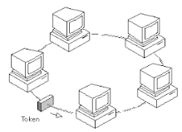

It is a networked ring in a LAN network, which connects all computers in a shape of a star topology which passes transfers logical tokens from different hosts. It one holding the token can send data only when the receipts of data confirmed are released.

* **Physical** -

**Star** -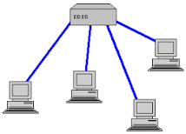

It is a topology for a LAN which connects all the node individually to the center point which is like a hub or a switch, it takes more cables but if a cable fails, only one node is affected.

**Ring** -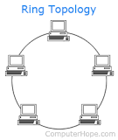

It is a network of topology which connects two other nodes, which forms a continuous path for signals through each node.

**Bus** -

It is a topology for LAN which connect all nodes with a single cable. It is called a backbone, if it is not strong it will destroy the entire segment.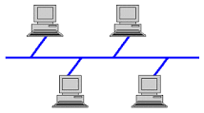

**Mesh** -

It is a topology which is a network where all nodes can share data with any linked system. It is used to in smart home, smart buildings, etc.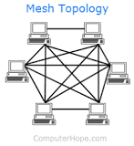

**Tree** -

It is a topology which is a network which connects each nodes which are shaped like a tree. They are usually used in business company organisations, and in databases.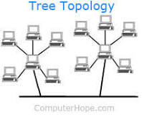

E - Explain how the following Protocols are used to support the above network :

* **Routed protocols** -

**IPv4** -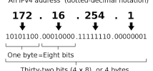

It is the fourth version of the internet protocol, which has the core standard for inter-networking methods.

**IPv6** -

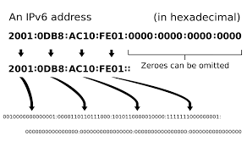

It is the sixth version of the internet protocol, which communicates by providing identity and location system which are for systems on the network and directs traffic across the internet. It is also aims to replace IPv4.

**FTP** -

It is used to transfer files from the computer to the network, it can be used to exchange files between system accounts, can be used to access files online or transfer them between accounts.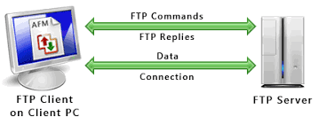

**HTTP** -

It isl used by the World Wide Web and this protocol defines how messages are formatted and transmitted, and what actions Web servers and browsers should take in response to various commands.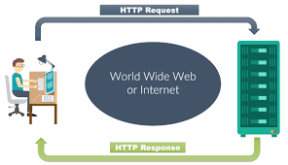

**SMTP** -

It is a Simple Mail Transfer Protocol which transferring emails using the internet through the network. It is stored in the server and transferred to the cloud to be send to the receiver.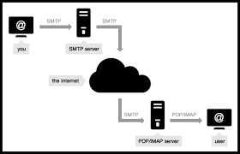

**SSL** -

It is a secure socket layer which helps encrypt data which is from a web server to a web browser, it ensure that the data is private, SSL certificate is used to create an SSL connection for a web server.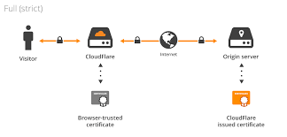

**VLSM** -

It stands for Variable-Length Subnet Masking which is the amount of subnetting subnets, it also allows network engineers to manage the IP address space into categories of subnet, without wasting addresses. 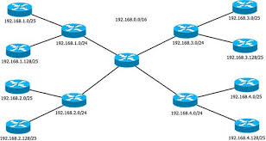

**Task 2 -**

Explain the following :

A - Networking devices :

**Servers -**

It is a computer program that provides a service to another computer programs. An application in a computer may function as a client with requests for services from other programs and also as a server of requests from other programs.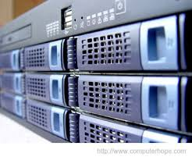

**Hub -**

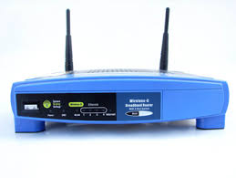

It is network hub, which connects nodes for different devices in a single network . This are usually used in LAN networks, which connects multiple ports, so that it copies to all other ports when it reach one port.

**Routers -**

It is a gateway where two or more networks connect, with each point which are present on the internet. It transfers packets from one network to the other networks to reach its final goal.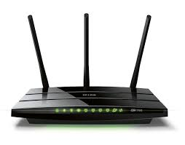

**Switches -**

It is a computer networking device that connects all the devices together on a network by using packets to receive, send and process data to the devices.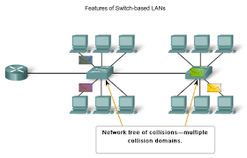

**HIDS -**

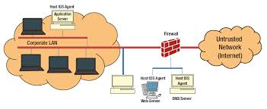

It is called a host-based intrusion detection system, helps monitor the computer system and network packets, which is similar to the network based intrusion detection system operates.

**Access Points (Wireless/wired) -**

It allows wireless devices such as routers to connect to a network. Some devices have in-built routers but some have to connect to the router to provide network access.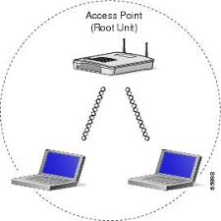

**Load Balancer -**

It improves the distribution of workloads across multiple computing resources, such as computers, a computer cluster, network links, central processing units, or disk drives.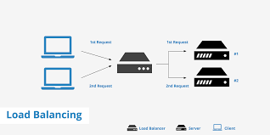

**VPN -**

It = extends a private network across a public network, and enables users to send and receive data across shared or public networks as if their computing devices were directly connected to the private network.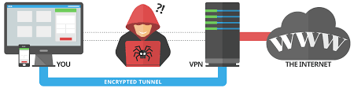

B - Networking softwares :

* **Client Operating System -**

It is a server OS, which is designed t run servers. These are operated within the client architecture to serve the client’s computer on the network. 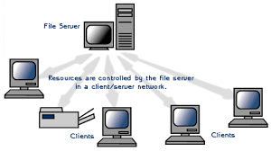

* **Server Operating System -**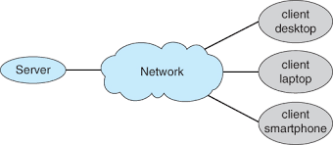

it is an operating system specifically designed to run on servers, which are specialized computers that operate within client/server architecture to serve the requests of client computers on the network.

* **Firewall -**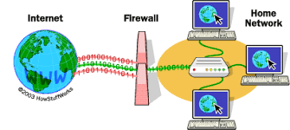

It is a network security system, which directs the incoming and outgoing network traffic. It is a barrier between the trusted internal network and untrusted external network.

C - Workstation :

* **Hardware -**

**Network card -**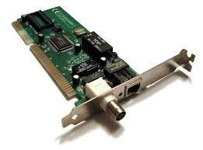

It is a computer hardware component that connects a computer to a computer network. Early network interface controllers were commonly implemented on expansion cards that plugged into a computer bus.

**Cabling -**

It is building or campus cabling infrastructure that consists of a number of standardized smaller elements called subsystems.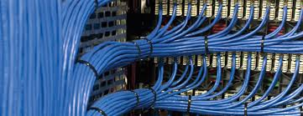

**File Permissions -**

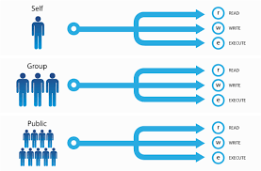

Most file systems have methods to assign permissions or access rights to specific users and groups of users. These permissions control the ability of the users to view, change, navigate, and execute the contents of the file system.

D - Server Type -

* **Web -**

It is a common way to access the internet on a system or a device also known as a web server, it is always connected to the internet. It is also eac web server is given an address which contains four numbers from 0 to 255.

The web server types are -

**Apache HTTP Server -**

It a web server developed by Apache Software Foundation. It also is an open source software compatible with most operating systems such as Windows, FreeBSD, Mac OS X, Linux, Unix.

**Internet Information Services -**

It is a high performance Web server from MIcrosoft, which runs on windows NT/200 and 2003 platforms. It comes inbuilt with windows NT/2000 and 2003 as it easier to administer on it.

**Lighttpd -**

It is an open source web server which is quick, secure and consumes less power from the CPU. It run on Windows, Mac, Linux and Solaris OS’s.

**Sun Java System Web Server -**

It is a free server which runs on Windows, Unix and on Linux. It supports different languages such as Python, Java, Ruby.

**Jigsaw Server -**

It is an open source server (W3C’s server), which is available for free and runs on Windows, Mac, Linux and Unix.

* **File -**

A file server allows users to share information over a network without having to physically transfer files by floppy diskette or some other external storage device.

* **Database -**

A database server is a server which houses a database application that provides database services to other computer programs or to computers, as defined by the client–server model.

* **Virtualisation -**

These are physical servers which are grouped into smaller virtual servers, each of which run in their separate operating system which are called guest operating systems.

The types of server virtualisation are -

**Hypervisor –**

It is a layer which is between the hardware and the operating system, which helps provide the required features and services for efficiently handling multiple operating systems.

**Para Virtualization –**

This one is similar to the hypervision as much of the emulation and trapping is software implemented virtualisation. The guest operating system is modified and then installed in the virtual machine.

**Full Virtualization –**

This one is similar to Para virtualisation, it emulates the necessary hardware required. The hypervisor traps machine operations which is used by the operating system which performs I/O.

E - Server Selection -

* **Cost -**

The cost of servers which are from Microsoft SharePoint are from $400 to $3000. These are mostly admin costs of the server, which are hardware and software, which are only a small portion of the ownership.

* **Purpose -**

The purpose of server selection are -

* It helps to share and store files.
* Manages a single internet connection for all the devices.
* Controls incoming and outgoing emails.
* It gives permission the open files when in a different location through Virtual Private Network.
* It helps share printers on a single server, which manages prints and shares them with others.
* It allows networked applications, which are users databases.
* It can allow hosting a private website on the internet.
* **Operating System Requirements -**
* Operating Systems. Windows XP.
* Versions. 10.0, 10.1, 10.2,
* Installation Type. .exe install.
* Processor. 2.0 GHz or faster Pentium 4-class CPU.
* Memory. 1GB.
* Hard Disk Storage. 1-10GB hard drive space.